*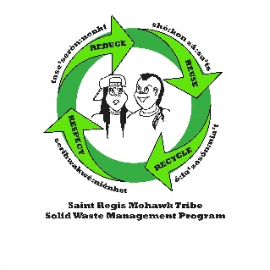***SRMT TRANSFER STATION**

*Notice: We reserve the right to reject any load or charge a ‘drag-out’ fee for non-municipal solid waste. Bulky material & construction debris must be three feet or less!*

|  |  |
| --- | --- |
| Material | 2024 Price |
| Municipal solid waste (up to 240 pounds) | $20.00 minimum or $165 per ton |
| Bulky & Construction Debris – Must be 3-4 feet or less | $180 per ton |
| Recyclables | $0/Residential $150/ton Commercial |
| Metals | $0 |
| Aerosol Cans 1 lb or less | $0 |
| Used Oil | $0 |
| Waste Oil | $1.50 per pound |
| Freon-containing appliances | $0 |
| Tires-Passenger car/Pick-up | $7.50 each |
| Tires Medium truck (9 or 9.5x17.5 to 19.5) | $7.50 each |
| Tires Heavy truck (10 or 11.5x22.5 to 24.5) | $25.00 each |
| Tires-Commercial (Farm tractor/Backhoe, semi/dump truck | $1.00/pound |
| Blue bags | $7.50/single or $35 for pkg. of 5 |
| Waste Lamp #1 (Straight Lamp) | $1.75 each |
| WL#2 (U-tube/Socket/Circular) | $0.50 Cents each |
| WL#3 (High Intensity Discharge) | $1.75 each |
| WL#4 (Shatter shields/Coated) | $1.45 each |
| WL#5 (Halogen & Incandescent) | $0.50 Cents each |
| WL#6 PCB Ballast | $1.00 each |
| WL#7 (Non-PCB Ballast) | $0.75 Cents each |
| WL#8 (Broken Lamps) | $2.00 each |
| E-waste (TV’s, Monitors, CPUs, Printers) | $7.50 per item |
| Mattress | $20.00 each piece |
| Assorted Batteries (Household up to Automotive) | $0 |
| Drag out fee – Removal of: HHW, E-Waste, tires, metals from  the Municipal Solid Waste Stream. | $35/item |
| Regional Fee collection of Solid Waste on the Saint Regis Mohawk Reservation which is not disposed of at the SRMT Transfer Station. | $60/ton |
| Return check fee | $50 plus collection fees |
| Uncovered/Unsecured loads | $35.00 in addition to tipping fee |
| Roll-Off/Dump Trailer Bin – Service Agreement is required for this service. Good Standing approval, then delivery is scheduled. | Prices start at $250 for 1-week rental-additional information and fees listed on Service Agreement |

SRMT Solid Waste Transfer Station

179 County Route 43

Fort Covington, NY 12937

(518) 358-4632

Email transfer.station@srmt-nsn.gov

Open Monday to Saturday: 7:00 am to 2:45 pm

Closed Thursdays except for Holiday weeks

We accept Cash, Checks and Credit Cards—U.S. funds only